Software Development

Requirements Definition:
The problem that is faced is lack of intuitive, multipurpose educational software in the area of mathematics.
The software solution should be easy to use, utilising the command line interface for simplistic control and feedback. The software solution also needs to be accurate and polished, to ensure the correct solution is given every time.

User Specifications:
The main user group who will be using this software are secondary students. They will need precise and reliable solutions and will need to independently operate the software without teacher guidance. The constraints of the main user group include the need to operate without teacher guidance and possible misunderstandings of software terminology.

Designing Algorithms

Structured Algorithm:
Calculator
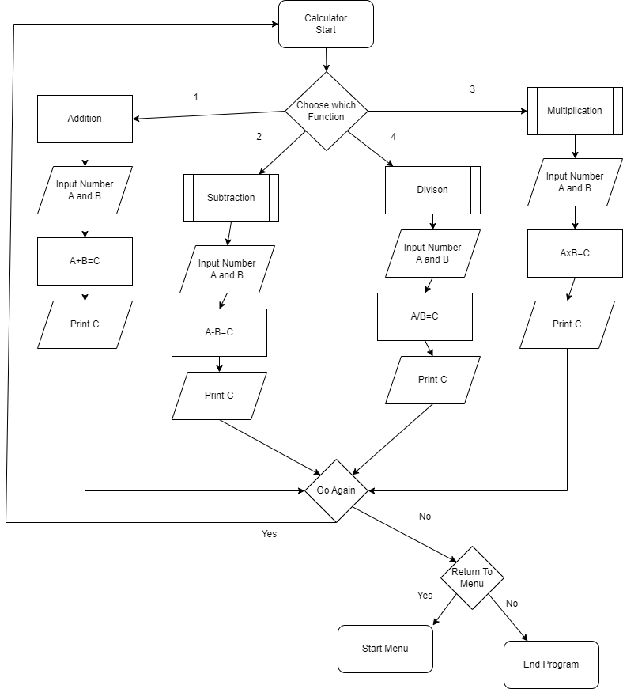
Morse Code
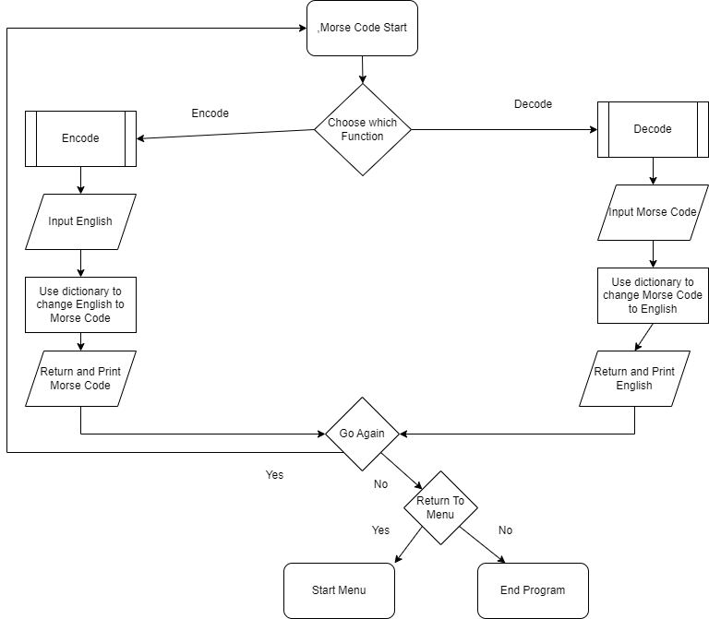
Tic Tac Toe
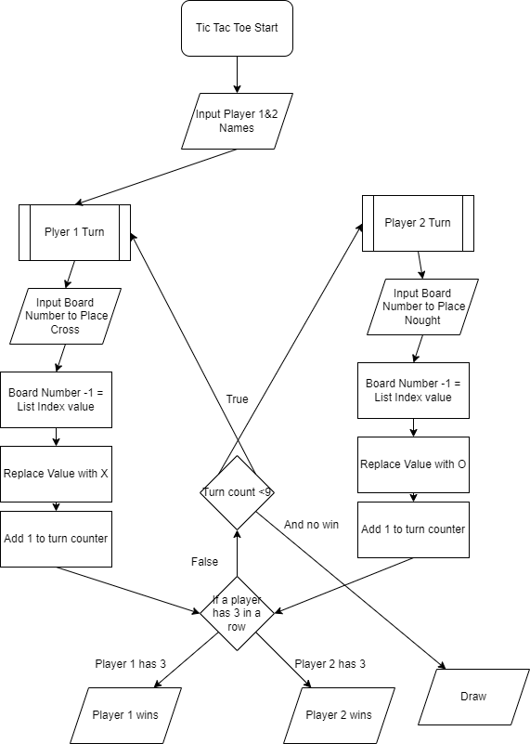

Triangle Identifier
Start
Input Side Lengths (float)
IF all sides are >0
IF the two smaller sides are equal or larger than the remaining side
IF all sides are Equal
Print Equilateral Triangle
ENDIF
IF 2 equal sides
Print Isosceles Triangle
ENDIF
IF all sides aren't equal
Print Scalene Triangle]
ENDIF
IF 2 sides squared equal the remaining side squared
Print Right Angled Triangle
ENDIF
Else
Triangle is impossible
Ask for retry
IF yes to retry then restart program
IF no then ask to return to menu
IF yes then return to menu
IF no then quit program
Else
Sides must be above 0
Ask for retry
IF yes to retry then restart program
IF no then ask to return to menu
IF yes then return to menu
IF no then quit program

Ask for retry
IF yes to retry then restart program
IF no then ask to return to menu
IF yes then return to menu
IF no then quit program
End

Structure Chart:
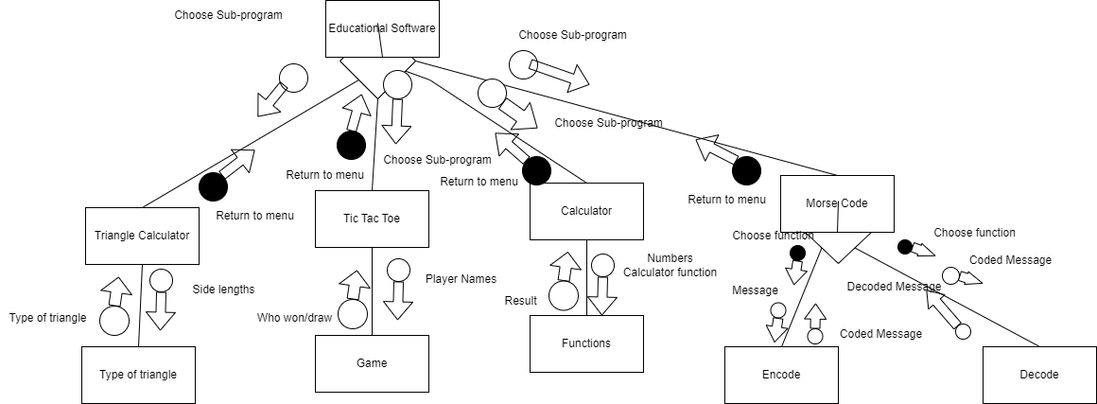

Data for Software Engineering

Define Data Types:
Define and discuss the use of the following data types.
- char and string
  - Characters (Chars) and Strings are the most basic text tool in python. A character is a single letter e.g “A”. A string is a larger data type, made up of many characters e.g “Hello 12!”
  - Chars are used for basic operations within the program. They are used when asking the user if they want to retry or return to the menu. The advantage of using a char is that only a single letter needs to be checked and stored, reducing storage use and allowing for faster code. The disadvantage is that complex phrases cannot be used, which may be useful for simplifying the length of the code.
  - Strings are used for more complex inputs and operations within the program. They are used mainly whenever the user needs to input a variety of characters or when the program needs to perform an operation with a text input. The advantage of a string is that it allows for large text inputs, this is useful in the Morse Code program. The disadvantage of a string is that it uses more memory.

- single precision floating point
  - A single precision floating point is a floating point number with 1 decimal number behind the integer.
  - Floats are used when there is a need for precise inputs. These numbers are used by the Calculator and Triangle Identifier. The advantage of a float is that it is precise for small inputs. The disadvantage is that a single precision float is still quite inaccurate and some operations involving them give wrong outputs.
- integer
  - An integer is a whole decimal number.
  - Integers are used when precision or accuracy isn’t the top priority, or isn’t needed. These are used throughout the Tic Tac Toe program to mark the board spaces. The advantages of an integer is that it uses smaller storage space, and mathematical functions work perfectly. The disadvantage is that a float is still good for mathematical functions, giving no reason to use an integer.

Data Dictionary:
Variable | Data type | Format | Size in Bytes | Description | Example | Validation
Option | String | “xxxxxx” | 472 | The variable that stores the users input to which program they would like to run | C, Calculator
Turncount | Integer | x | 28 | Counts the turns in Tic Tac Toe | 6 | Start 0
WinCombo | List | [x,x,x] | 120 | A list of all possible winning combinations in Tic Tac Toe, shown in the index value (the number on the board -1) | 0,1,2
SideA | Float | x.x | 24 | Length of Side A | 1.1 | Must be above 0
SideB | Float | x.x | 24 | Length of Side B | 2.2 | Must be above 0
SideC | Float | x.x | 24 | Length of Side C | 3.3 | Must be above 0
rt | String | “x” | 42 | input for retry | Y
ry | String | “x” | 42 | input for retry | N
re | String | “x” | 42 | input for retry | Y
MorseDictionary | Dictionary | “x”:”y” | 832 | A dictionary storing the English letters and the equivalent Morse Code | A: .-
Message | String | “xxxxxx” | 52 | The English message that is turned into Morse Code, or returned when Morse Code is decoded | Hello World
Morse_Code | String | “xx xx xx” | 52 | The Morse Code that is turned into English, or returned when English is encoded | .... . .-.. .-.. --- .-- --- .-.. -..

Data Structures:
Define and discuss the use of the following data structures.
- Arrays
  - An array is a collection of values that are stored within the memory for use at a later time. In my program I use many data arrays, including: lists, sets and dictionaries. Different array types are used for different purposes.
  - Lists are used in the Tic Tac Toe program to store information related to the game, including what board squares a player has a nought or cross in, what squares are needed to win the game and what squares are on the board. Lists can be changed and read throughout the program which makes them the best choice for a game like Tic Tac Toe
  - Sets are used whenever a decision requiring user input is made. The sets store the accepted responses to the decision, and check whether the user’s input fits within a certain set. This allows easy choice of program for the user as many different variations of responses can be stored e.g words can be stored in no-caps, ALL-CAPS, Some-Caps which means that if the user inputs any of them, the program will still run without needing a single super specific input
- Trees are used for sequential operations. They allow sequential Boolean decisions. Trees can be used to sort inputs into lists.

Developing Solutions with Code
Convert Algorithm into Code using:
- control structures
- data structures
- standard modules
- subprograms
comments in code

Debugging Tools:
The main debugging tool used in this project was the Visual Studio Code debugging tool. The tool was used to discover syntax errors in small parts of code.
The terminal was also used to provide details about these errors

Data Structure:
Morse Code Dictionary
Tic Tac Toe Winning Combinations

Coding Errors:
Error | Type | Discovery | Effect | Solution
User could only choose subprogram by inputting one value | Value | Testing a new program, inputted wrong spelling, program ended. Upon further testing and adding more accepted inputs, the error still happened. Checked discussion forums for similar problems, discovered my error | Program was prone to typo and spelling errors, sometimes if no valid value was entered a program would still run | Changing IF statements from: IF input == “calculator” or “Calculator” -would only allow “calculator” inpu Calculator, calculator, c, C, etc..}  IF input IN Option 1 -allows for use of multiple phrases. The user only enters 1 phrase, it is checked against the set to see if it is in the set, if it is then the IF is true
Functions would run upon starting the program | Syntax | Started the program after implementing functions, they all immediately started without input from the user | Functions would run without user input | 2 solutions were implemented.  - functions were only defined and called when needed in the code (defeats the purpose of a function)  - Not calling the functions after they had been defined.

